# Storytelling and business presentations

## 6.1 Storytelling

#### Introduction

Data visualisation is regularly advocated for its capability to tell stories within data, yet these data stories vary in critical ways from traditional forms of storytelling. Storytelling with data and analytics requires the ability to explain complex trends and data points to clients.

It would help if you were a good data storyteller to concisely convey why your clients should continue to invest in your services to continue to grow.

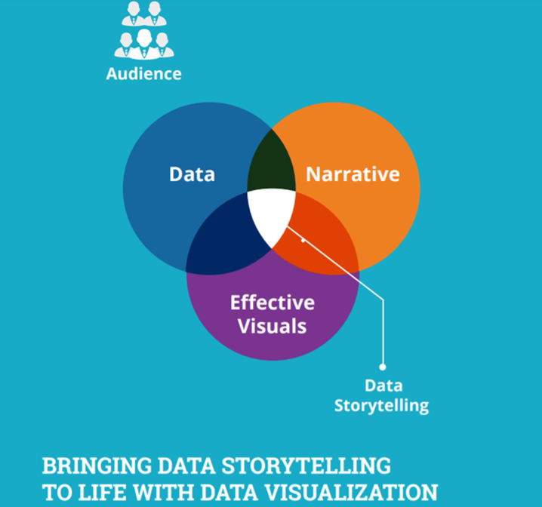

Source: (Infocepts, n.d.)

#### Activity: Data story

Refer to the following column chart for quarterly reviews of the four most popular fast-food chains. Briefly describe what makes this data story interesting.

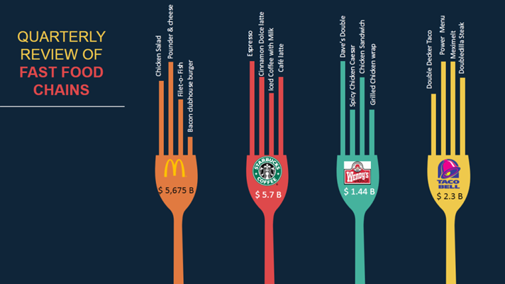

Source: (Malhotra, 2017)

#### Does storytelling make a difference?

**Explore: Storytelling's impact**

Why does storytelling make a difference?

Data’s potential allows it to be analysed and its trends interpreted and presented so that everyone can understand. This process transforms the data into something immensely valuable, i.e., it turns it into a story.

Without a story, presenting your data as a series of unconnected charts and graphs could result in the audience struggling to understand it – or worse, deriving incorrect conclusions. This, in turn, can lead to faulty decision-making and critical outcomes for the business.

The following are the five signs that indicate that you’re not telling a compelling story:

* blank stares
* too many questions about the validity of data
* difficulty retaining information
* uncertainty about next steps
* doubts about why data matters.



Although they’re often thought of as the same thing, data visualisation does not equate to data storytelling. However, visualisations are still a critical component of convincing storylines.

#### Lessons in storytelling

The following are the five key lessons in storytelling:

1. Know your audience

Before you start telling your story, think about whom you’ll tell it to. Consider what holds their attention, where their interests lie, and how best to connect with them. To win an audience over, you must understand where they’re coming from and then connect with them emotionally and individually.

* Whom are we presenting to? What are their goals? Are they technical or casual? Do they prefer the big picture or little details?
* What do we want them to know? What’s the most important takeaway? What feeling should they walk away with? Wonder? Insight? Enthusiasm?
* What action do we want them to take? Do we want them to share this story with others? Understand a trend in a new light? Make a brave decision?

When thinking about your audience, remember that different team members have different objectives and opinions. Effective data storytelling should cater to these differences. One great place to start is by considering your audience’s level of understanding of the topic you’re presenting:

* ****Beginner****: New to the subject but keen for deeper knowledge
* ****Generalist****: Mostly concerned with major themes and high-level analysis
* ****Supervisor****: Search for actionable insights, as well as access to details
* ****Executive****: Time-conscious and requires inferences and implications upfront.

1. Choose the right data

To tell a clear and compelling story, you need to split the signal (required data) from the noise(all data sources) and choose the right data for your needs:

* Identify the subsets of data representing the specific points you want to deliver
* Remove any irrelevant data that is not crucial to your story – displaying too much information makes it hard for readers to spot the insights you want them to see
* Use metrics and naming conventions that your audience will identify – like capital spending, change in sales, or time to hire

Start by asking yourself what the [visualisation needs to accomplish](https://activewizards.com/blog/how-to-choose-the-right-chart-type-infographic/" \t "https://elearn.sunway.edu.my/webapps/blackboard/execute/_blank) (https://activewizards.com/blog/how-to-choose-the-right-chart-type-infographic/) – different visualisations have different strengths and weaknesses.

1. Draw attention to key information

To be a real data storyteller, you need to direct your audience’s attention to the most crucial points within your data by guiding them. A few simple [design tricks](https://twooctobers.com/blog/8-data-storytelling-concepts-with-examples/" \t "https://elearn.sunway.edu.my/webapps/blackboard/execute/_blank) can help you bring attention to where it’s needed most. You must also focus on the preattentive attributes. Preattentive attributes are visual elements that are instantly documented by our iconic memory (ultra-short-term memory part of the visual memory system). They help draw attention to the most important parts of a visualisation.

Common pre-attentive attributes include:

* ****Colour****: Alert users to the most critical points by using a bold colour like red or orange
* ****Placement****: Help users quickly grasp the purpose of a data visualisation by placing its title in the top-left portion of the page
* ****Size****: Draw attention to the most important chart or graph by making it the largest element on the page

1. Develop a narrative

To truly drive involvement and encourage action, you need to connect with the audience logically and emotionally by using your data to create a compelling narrative. If you exhibit your data without providing the context, your audience will just take transitory notes without really retaining any of the insights you’ve shared.

Craft your narrative using the following elements:

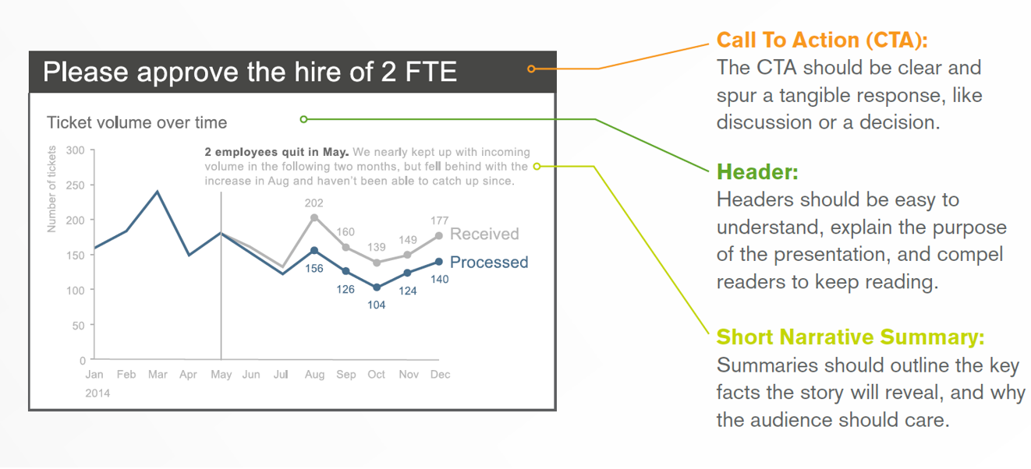

Source: (Nussbaumer, 2011)

1. Engage your audience

Stories momentarily circumvent our logical filter to involve us on an emotional level – where conclusions are made. Engrossed in a story, we momentarily keep aside our disbeliefs and listen with less suspicion. Hence, stories keep us fixated on the big picture rather than the ornate details. This brings advantages for data storytellers. The right analytics solution allows data stories to be:

1. Interactive

When your audience raises questions, you can easily go back to the data and find answers in real-time with collaborative analytics using tools like:

* Filters to control what data is shown in the visualisation.
* Separate pages to break large problems into smaller, more workable elements.
* Windows of analysis for entering new data to be analysed.

However, to provide this level of interactivity, you need tools that are both powerful and spontaneous and lets anyone explore– fast and easy.

1. Shareable

Data stories can transform businesses, but to amplify their impact, you need to share them easily with your team, across your business, and out to your customers. New analytics technologies are making it easier than ever to share information.

1. Centralised

By placing your stories in a consolidated location, you can provide a repository of valuable information that can be accessed repeatedly – or help make new stories.

#### Concepts of storytelling for communicating with data

The key concepts to keep in mind when designing the structure of any presentation which will communicate processed data or information are:

1. Trends

Trend stories typically focus on how numbers rise and fall over time. However, a flattening trend can also echo key insights that help the audience to dive deeper.

1. Comparison

By comparing different data sets and how they change over time, you can analyse trends within a wider context.

1. Rank Order

A league table (https://www.researchgate.net/figure/Rank-order-of-things-which-are-important-for-your-quality-of-life_tbl1_233136669) is a useful tool for showing hierarchy based on a variety of factors to make a large amount of data consumable. Here’s an example of a rank-order table from ResearchGate.

1. Statistical relationships

By exploring the correlation between data sets, you can predict how one factor may impact another.

1. Counter intuitive data

Surprising or counterintuitive data stories and visualisation can hold attention, temper curiosity, and invite your audience to get interactive with the content.

To craft a convincing data story, you can use these key elements:

1. The Plot:

The plot involves the questions you’re tackling, how you plan to answer them and how you will help the audience conclude. Your data visualisation should take your audience from point X to point Y in the most productive and real way possible.

1. The setting:

This context will affect how your audience interprets the data. Meeting your audience where they’re at helps place your data and insight for the maximum impression. Examples include historical data, current developments, and industry benchmarks.

1. The Characters:

The audience you’re addressing will govern how you tell the story. The story should have the right tone, address the audience’s priorities, and explain how the insights can help them achieve their goals.

1. The End

Reach a consistent deduction with the topic or challenges you set out to address. It could be a summary of what the audience has learned from the data story, how they can attain results or what they should do otherwise in the future to improve consequences.

Your data visualisation graphics should be self-explanatory so they can either be embedded in a content piece or used as a standalone. In addition, you can use interactive data visualisation, such as animation, maps, or word cloud, to add interest and increase involvement.

Your data visualisation should impartially present the facts, even if you’re using the data to support a specific idea. Any dishonest manipulation can create discrepancies that reduce your credibility and the audience’s faith in your information, whether intentional or unintentional.

To present your data empirically, use proper labelling to avoid uncertainty, match graphic dimensions with data dimensions and confirm that the design elements aren’t misrepresenting the data.

In addition, take an unbiased approach when selecting information for your data story. For example, don’t use discrete values when data is continuous. Be clear about treating missing, outlier or out-of-range values and be transparent when using arbitrary temporal ranges, capped values, volumes, or intervals.

The following reading is recommended for further understanding.

* Sunarto N. (2023, June 22). 55 Facts and Statistics Showing Why Data Visualization Is Important. Piktochart. <https://piktochart.com/blog/data-visualization-statistics/>

### 6.1.1 Storytelling framework

While there are many description models and dramatic frameworks you can follow, there is one that you can adopt to build your story. The following is known as Freytag’s pyramid by Gustav Freytag.

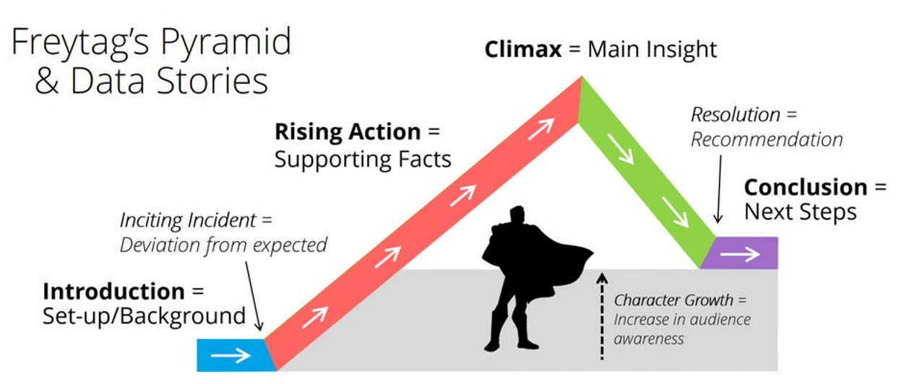

Source: (Dykes, 2016)

**This consists of 5 main phases**:

Phase 1: Exposition

This is where the background and context are introduced, and the key players (or characters) are showcased to the audience.

Phase 2: Rising Action

This phase introduces facts such as visualisations to help support the narrative and the key message for the audience’s takeaway.

Phase 3: Climax

This phase highlights the key takeaways or challenges. It is the turning point where decisions need to be made to solve a challenge, or dire consequences will have to be faced.

Phase 4: Falling Action

This is the phase where the dire consequences (or catastrophe) are explained with a hint of a slim possibility of reversal (backed up with statistics and data, of course).

Phase 5: Resolution

Finally, the story is concluded with a ray of hope and actionable insight and steps that the audience can immediately act upon to reach the ‘promised land’.

In today’s environment in which we’re besieged by data and struggle to make sense of it, data-driven storytelling offers a valuable tool that not only presents the data, but adds context, meaning, relevance and clarity to help the audience interpret the information and extract value from it. (Dyke, 2016).

#### Benefits of storytelling

Here are some benefits of using data storytelling as a communication tool:

1. Data stories add value by sharing data’s significance and context so the audience can connect the dots and turn figures into insights that they can use. The insights, in turn, enable decision-making and drive actions.
2. By using numbers and facts, you can secure your assertions and increase the credibility of your content. Thus, building trust with your audience and increasing the likelihood that your point-of-view will convince them.
3. Data stories crafted with core and exclusive data help you stand out and catch attention. The original insights, useful viewpoints and unexpected angles allow you to cut through the clutter.
4. The blend of narrative and visual elements stimulates both sides of the brain, delivering an analytical and emotional experience to help your audience reinforce the information through understanding, memory, and appeal.
5. Different techniques, such as interactive data visualisation, can help engage with the audience, for example, by asking them to arrive at a deduction or exploring the part of the data story that’s most pertinent to them.

Watch this video of 1 minute 40 seconds to further explore this topic. <https://youtu.be/jHuevtXN7R8> *Source: ([ImagineLayout](https://www.youtube.com/@Imaginelayout" \t "https://elearn.sunway.edu.my/webapps/blackboard/execute/_blank), 2015)*

The following readings are recommended for further understanding.

* Sharday. (2015, February 13). 6 creative ways to present your market research data. Insightrix Research. <https://insightrix.com/6-creative-present-research-data/>
* Segel, E., & Heer, J. (2010). Narrative visualization: telling stories with data. IEEE Transactions on Visualization and Computer Graphics, 16(6), 1139–1148. DOI: 10.1109/TVCG.2010.179. <http://vis.stanford.edu/files/2010-Narrative-InfoVis.pdf>

### 6.1.2 Investigate the use of Freytag's Pyramid

#### Activity: Freytag's Pyramid

****Time****: 30 minutes

****Purpose****: Investigate the use of Freytag's pyramid

****Task****: Visual, data-driven storytelling is an exceedingly effective way to win attention. At LinkedIn, the marketing teams turn to infographics because they take advantage of the audience’s preference for visual content and insights while delivering a narrative in a consumable format—something that a reader could munch in just a couple of minutes.

Refer to the two links given below and review the infographics in each. Can you identify the use of Freytag’s Pyramid in these data stories? Justify your answer.

* Kaplan, A. (2016, January 6). *3 powerful examples of visual, data-driven storytelling*. Linkedin.Com; LinkedIn. [https://www.linkedin.com/pulse/3-powerful-examples-visual-data-driven-storytelling-andrew-kaplan/](https://www.linkedin.com/pulse/3-powerful-examples-visual-data-driven-storytelling-andrew-kaplan/" \t "https://elearn.sunway.edu.my/webapps/blackboard/execute/_blank)
* LinkedIn. (n.d.). *How affluent millennials are reshaping the future of finance*. Slideshare.Net. Retrieved March 25, 2022, from [https://www.slideshare.net/LImarketingsolutions/how-affluent-millennials-are-reshaping-the-future-of-finance](https://www.slideshare.net/LImarketingsolutions/how-affluent-millennials-are-reshaping-the-future-of-finance" \t "https://elearn.sunway.edu.my/webapps/blackboard/execute/_blank)

****Feedback****: To help further the conversation, respond to the posts of at least 2 of your peers. You can ask them questions for clarification on their approach or provide them with feedback. Your facilitator will moderate this discussion.

6.2 Business presentation

Data visualisation helps people analyse data quickly and proficiently. Providing easy-to-understand visual representations of data helps employees make more well-versed decisions based on that data. Presenting data in visual form can make it easier to understand and enable people to obtain insights more quickly. Visualisations can also make it easier to transfer those insights. Visual representations of data can also make it easier to see how independent variables relate.

The analyst’s job is to effectively communicate the output to the target audience, such as the organisational team or a company’s external investors. This requires focusing on the main points, facts, insights, and references that will prompt the needed action from the audience.

Here are some key objectives to think about when presenting any data analysis:

1. visual communication
2. audience and context
3. charts, graphs, and images
4. focus on important points
5. design principles
6. storytelling
7. eloquence
8. dashboards

#### Activity: Do you know your basics?

1. Before you start to create a storyboard, what is the first thing you should know? Your story
2. After you have figured out your storyline, what should be the next thing to focus on? Character development
3. A dynamic visual medium produced from static drawings, models, or objects posed in a series of incremental movements that are then rapidly sequenced to give the illusion of lifelike motion. Animation
4. You have determined the audience of your presentation and topic. What step have you completed? Determine the purpose
5. What should we do to get attention from the audience...? Tell them what you are going to tell them

###### **Process of constructing business presentations**

Given our preference for stories rather than a bare recitation of facts, it’s not surprising that data storytelling has quickly captured the attention of business analysts and data researchers.

Businesses that face user acceptance challenges struggle to provide spontaneous and competent access to the insights. Their ability to visually represent huge amounts of data is critical for supplementing their users’ decision-making capabilities. An in-depth understanding of the tasks faced by users in the changing business environment is essential for improving user adoption. The following template captures elements critical for data storytelling such as Problem Statement, Project Objective, Target Users, Key Metrics, Technology Stacks, Key Project Deliverables, and Success Metrics.

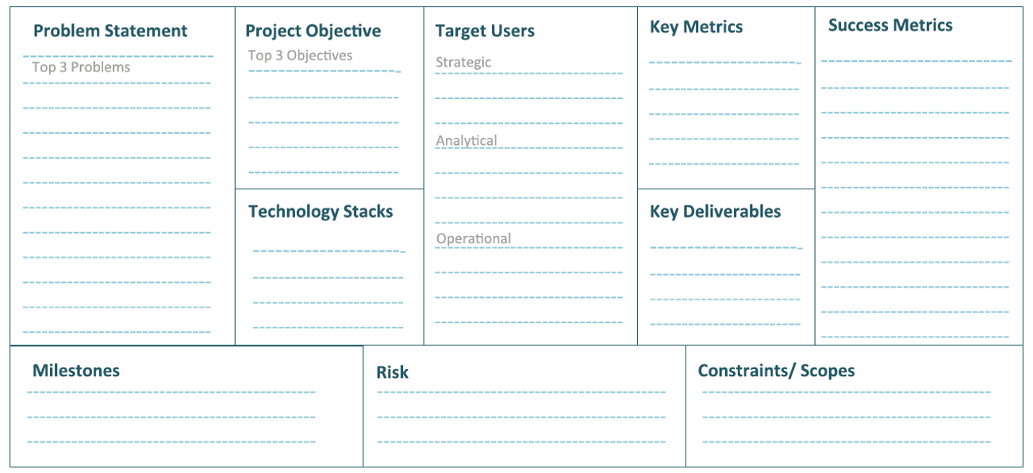

Source: (Infocepts, 2019)

The five-step process of constructing a business process by defining user-requirements includes:

1. Identify data sets: This step requires converting categorised ideas from the data sorting activity into actual data sets.
2. Grouping the data: This step creates a cluster of similar reports by grouping them in logical order.
3. Prioritising the data: Data is chronologically arranged into primary, secondary, and tertiary categories at this stage.
4. Sequencing the data: This process concludes with visual hierarchy led data sequencing. According to visual hierarchy, the top left section of any presentation serves as a high perceptibility area, making it ideal for principal insights. It establishes a persuasive and consistent flow for data storytelling. It is vital to establish relationships between insights and their hierarchies to gain a 360-degree view from the highest to the lowest level.
5. Ideating: The next step is to build a business presentation with a visual picture of screens, information, or actions in sequential order. The aim is to build a visual narrative that revolves around users and enables them to visualise all solution complexities.

### 6.2.1 Tips to consider while preparing a client report for visualisation

#### Introduction

What is client reporting, and what makes it so critical?

Client reporting is designed to offer clients a regular summary of the work done and where their project stands. Based on these monthly (or bi-monthly, or weekly) reports, you can hold discussions with those clients and focus on how you’ve been delivering results for them.

Client reporting is therefore one of the most direct and effective ways to build the client’s confidence in you. Clear and well-written client reports are a tool to develop and improve the business-client relationship. This is how-

1. client reporting lets you interact with your clients regularly
2. it allows for transparency
3. you get to educate your clients
4. it keeps the clients accountable too
5. it lets you show off your successes

**How to prepare a client report**

1. Create a questionnaire for your client

Before working with your client, create a questionnaire to onboard them; this lets you understand your client and their goals better and decide what information your reports should include equally. Some questions you could ask in this questionnaire include:What are your goals for your brand?

* What are your monthly targets?
* What are your goals for this project?
* What metrics would you want to use to measure the success of this process?
* Who is your target audience?

The following image illustrates a few questions you can ask your clients.

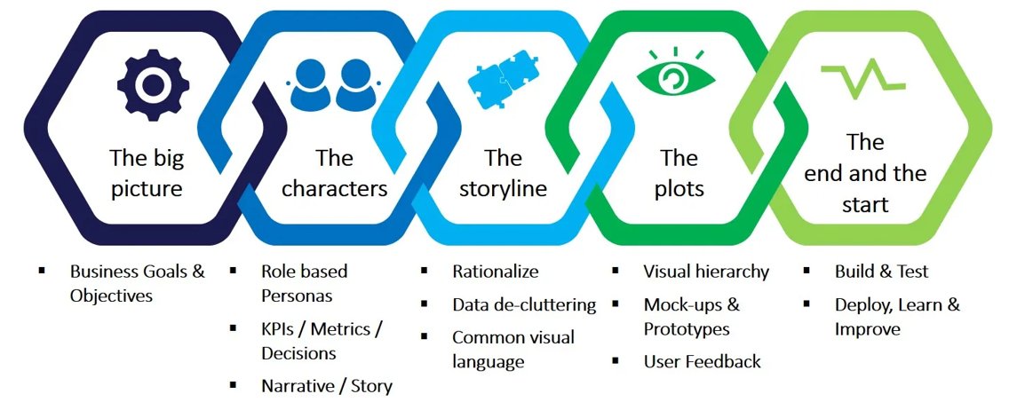

Source: (ITC Infotech, 2020)

1. Identify metrics and KPIs for the project

Before starting on a project for your client, you should jointly agree on how to define its success by figuring out what KPIs and metrics you will use to measure your efforts. These depend on the kind of project you’re working on.

1. Determine the frequency of your reports

Decide on how often your client will receive reports so you can efficiently assign enough time and labour to each report. Even if you have automated your client reporting process, you still need to add explanations and insights to the report.

1. Automate the process

Client reporting is a time-consuming process, but you can use plenty of automation tools to lessen the dullness of using spreadsheets and manual reporting. Automating tools also reduce the risk of errors and allow for uniformity in presentation.

1. Add a monthly summary

No client report is the same; the details alter based on the kind of project you’re working on. However, all reports should contain a monthly summary (https://piktochart.com/blog/).

1. Prioritise information by relevance, and engage clients visually

ExaWeb Corporation co-founder & Technical Director Patrick Garde says:

“A couple of the best practices we implement are that we show the relevant data first and we add visuals to our reports. We make sure we display all the vital data upfront in our reports. If the client is an SEO client, we show the growth of organic traffic as well as the improvement of ranking position. If the client is a PPC (pay-per-click) client, we show how much they spent, and how many converted. We believe that our clients should know what is going on in their digital marketing campaigns.

Also, we add images to our reports as some clients want to see visuals. It gives them data visual representations to help them understand the report better, as well as help them decide on the next steps of the campaign.”

#### Strategies for effective storytelling

Here are three strategies for effective storytelling:

1. The spoken and written narrative

Each format presents its opportunities and challenges. While giving a presentation, a good portion of your story will be spoken. Whereas if you’re sending an email or a report, the narrative is likely entirely written. A live presentation has the advantage of words on the screen or page being supported by the words you speak. In this manner, your audience can read and hear what they need to know, reinforcing the information.

However, live presentations present two challenges.

* You must safeguard what your audience must read on a given slide or section. The content of the on-screen text must not divert their attention from listening to you.
* Your audience may act impulsively. They can ask questions off-topic, jump to a point later in the presentation, or do other things to push you off the path.

Therefore, it is important to clearly understand the role you want your audience to play and how your presentation is designed. Telling your audience how you will structure your presentation helps them know what to expect and what role they are meant to play.

1. The power of repetition

While we establish narrative structure and flow, the power of repetition is another strategy we can leverage within our storytelling. By repetition, important information is gradually transferred from short‐term memory into long‐term memory. The more the information is repeated or used, the more likely it will end up in long‐term memory or be retained.

1. Storytelling and the written word

The following are a few great tips by Cole Nussbaumer Knaflic on how to write with style:

1. Find a subject you care about. It is this genuine caring, and not your games with language, which will be the most compelling and seductive element in your style.

2. Do not ramble, though.

 3. Keep it simple. Great masters wrote sentences which were almost childlike when their subjects were most profound. “To be or not to be?” asks Shakespeare’s Hamlet. The longest word is three letters.

4. Have the guts to cut. If a sentence, no matter how excellent, does not illuminate your subject in some new and useful way, scratch it out.

5. Sound like yourself. I find that I trust my own writing most, and others seem to trust it most, too, when I sound most like a person from Indianapolis, which is what I am.

 6. Say what you meant to say. If I broke all the rules of punctuation, had words mean whatever I wanted them to mean, and strung them together higgledy‐piggledy, I would simply not be understood.

7. Pity the readers. Our audience requires us to be sympathetic and patient teachers, ever willing to simplify and clarify.

* Nussbaumer Knaflic, C. (2015). *Storytelling with Data : A Data Visualization Guide for Business Professionals*. John Wiley & Sons, Incorporated. [https://ebookcentral.proquest.com/lib/sunway/detail.action?docID=4187267](https://ebookcentral.proquest.com/lib/sunway/detail.action?docID=4187267" \t "https://elearn.sunway.edu.my/webapps/blackboard/execute/_blank)

#### Tactics to support clear storytelling

The following are a few tactics to help ensure that your story is clear:

1. Horizontal logic

Horizontal logic only employs the ability to read each slide's slide title throughout your deck, and together, these extracts tell the predominant story you want to communicate. It is important to have action titles (not descriptive ones) to work well. One strategy is to have an executive summary slide up front, with each bullet corresponding to the following slide title in the same order.

1. Vertical logic

Vertical logic signifies that all information on a given slide is self‐reinforcing. The content reinforces the title and vice versa. The words reinforce the visual and vice versa.

1. Reverse storyboarding

When you storyboard at the beginning of building communication, you craft the outline of the story you intend to tell. As the name implies, reverse storyboarding does the opposite. You take the final communication, flip through it, and write down the main point from each page. The resulting list should look like the storyboard or outline for the story you want to tell.

Watch this 7-minute 35-second video to explore five business presentation design lessons from Steve Jobs. <https://youtu.be/iJq-thyDF9Q> *Source: ([St George International School of English](https://www.youtube.com/@EnglishSchoolLondon" \t "https://elearn.sunway.edu.my/webapps/blackboard/execute/_blank), 2013)*

Refer to the following readings to extend your understanding.

* Nussbaumer Knaflic, C. (2020, May 21). The structure(s) of story. Storytelling with Data. https://www.storytellingwithdata.com/blog/2020/5/21/the-structures-of-story
* Client dashboard & report examples for effective reporting. (n.d.). Datapine.Com. Retrieved March 25, 2022, from <https://www.datapine.com/articles/client-dashboard-report-examples>

### 6.2.2 Understanding business presentation

#### Activity: Putting EV valuations into perspective

****Time****: 30 minutes

**Purpose**: Understanding business presentation

****Task****: Look at the Visual story related to EV’s valuations below and answer the following questions.

**Questions**:

1. Looking at the valuations, which company makes Tesla go on the ‘defensive’?
2. What keeps the EV companies at lower sales compared to Legacy car makers?
3. Justify the following statement with numbers -   
   “At the end of 2021, Tesla and its four EV rivals were worth a combined $1.3 trillion. This was more than double that of the legacy group, which was worth $635 billion.”

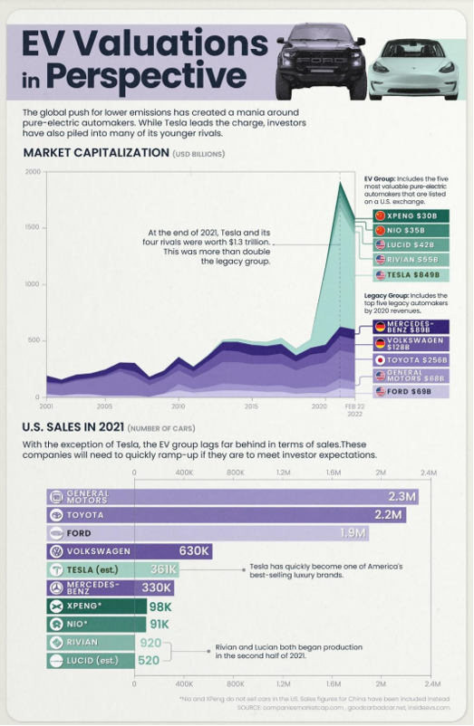

*Source: ([Marcus Lu](https://www.visualcapitalist.com/putting-ev-valuations-into-perspective/" \t "https://elearn.sunway.edu.my/webapps/blackboard/execute/_blank), 2022)*

****Feedback****: To help further the conversation, respond to the posts of at least 2 of your peers. You can ask them questions for clarification on their approach or provide them with feedback. Your facilitator will moderate this discussion.

## 6.3 Planning a data driven story

#### Introduction

When adapting your data into a captivating narrative, always frame that information within its wider context. If you don’t appropriately contextualise your data, you might ignore the larger picture or tell a fundamentally erroneous and compromised story.

#### Activity: Explain with visuals, narrate with words

The following visualisation is very compelling to look at and draws the user’s attention. Write a narrative of 50-100 words on what this visualisation conveys.

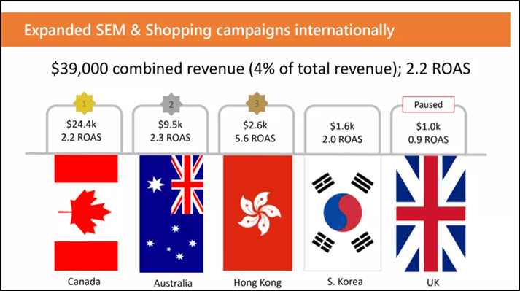

#### Planning a data driven story

###### **Data driven storytelling process**

Visualisation research on storytelling mainly focused on how data visualisation components contribute to communication, including a constructive process such as the crafting of narrative structures. Refer to the image below.

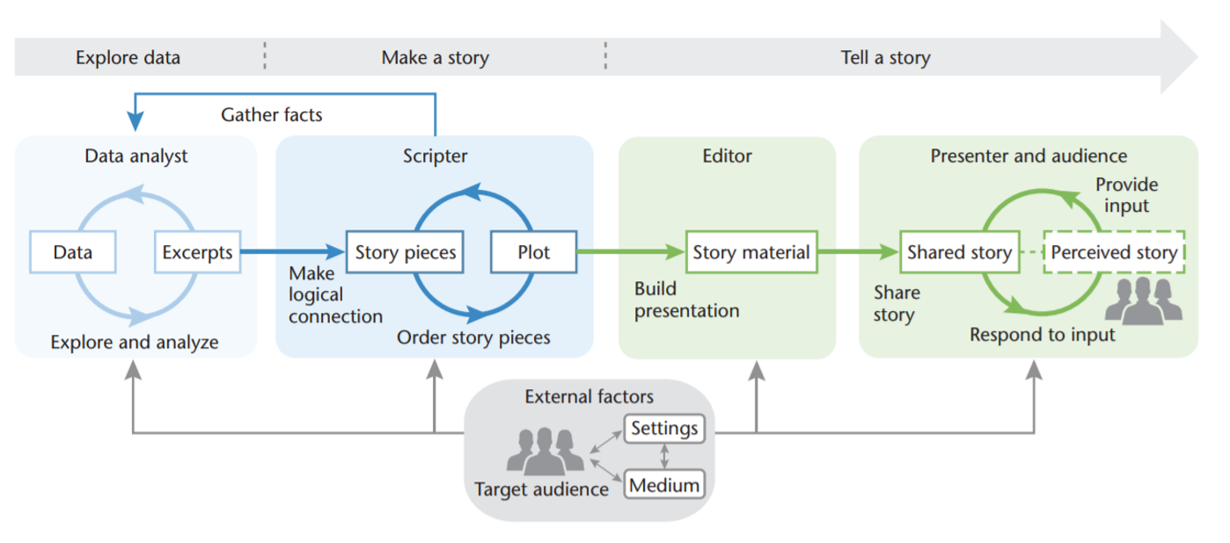

*Source: Storytelling process ([Lee, Riche, Isenberg, Carpendale](chrome-extension://efaidnbmnnnibpcajpcglclefindmkaj/viewer.html?pdfurl=https://www.microsoft.com/en-us/research/uploads/prod/2016/12/StorytellingProcess-CGA2015.pdf&clen=945742" \t "https://elearn.sunway.edu.my/webapps/blackboard/execute/_blank), 2015)*

Charts, graphs, and diagrams provide an important visual aid that will help tell your story. These interpretations of data can also offer information that might emphasise secondary narratives or conversations that, although not vital to your main point, could be fascinating stories.

Your visuals should also match the theme of your story. Working with a professional creator who understands how different visual elements refer to different emotions will help strengthen your general message and narrative.

Watch this 3-minute 43-second video to explore some more storytelling tips. <https://youtu.be/9UNlHFfy4hs> *Source: ([Heroic Public Speaking](https://www.youtube.com/@HeroicPublicSpeaking" \t "https://elearn.sunway.edu.my/webapps/blackboard/execute/_blank), 2019)*

Refer to the following readings to extend your understanding.

* Avidon, E. (2020, September 9). *Data-driven storytelling opens analytics to all*. SearchBusinessAnalytics; TechTarget. [https://www.techtarget.com/searchbusinessanalytics/feature/Data-driven-storytelling-opens-analytics-to-all](https://www.techtarget.com/searchbusinessanalytics/feature/Data-driven-storytelling-opens-analytics-to-all" \t "https://elearn.sunway.edu.my/webapps/blackboard/execute/_blank)
* Jock Mackinlay, J., Kosara, R., Wallace, M. (n.d.). *Data Storytelling Using visualization to share the human impact of numbers*. Oregonstate.Edu. Retrieved March 25, 2022, from [https://web.engr.oregonstate.edu/~mjb/cs553/Projects/Papers/whitepaper_datastorytelling.pdf](https://web.engr.oregonstate.edu/~mjb/cs553/Projects/Papers/whitepaper_datastorytelling.pdf" \t "https://elearn.sunway.edu.my/webapps/blackboard/execute/_blank)

### 6.3.1 Practice your data storytelling skills

Activity: Tell us an interesting story

****Time****: 30-45 minutes

****Purpose****: Computing tools allow people from all different fields to learn from data. By transforming and visualising data, we can find patterns that help us learn about our world. The goal of this activity is to put into use all the data story skills you have practiced throughout this week.

****Instruction****:

1. Download the [dataset](https://www.kaggle.com/datasets/bahramjannesarr/nobel-prize-from-1901-till-2020" \t "https://elearn.sunway.edu.my/webapps/blackboard/execute/_blank) https://www.kaggle.com/datasets/bahramjannesarr/nobel-prize-from-1901-till-2020.
2. Use Tableau to make a visualisation that can teach something interesting about the data. Share the visualisation in the discussion forum.
3. Answer the following questions

**Questions**:

1. What information does your visualisation show?
2. What new insights or decisions can be made based on this visualisation?

****Feedback****: To help further the conversation, respond to the posts of at least 2 of your peers. You can ask them questions for clarification on their approach or provide them with feedback. Your facilitator will moderate this discussion.

### 6.3.2 Activity: Present the carbon footprint of transportation

#### Activity: Present the carbon footprint of transportation

****Time****: 30-45 minutes

****Purpose****: The goal of this activity is to put into use all the data story skills they have practiced throughout this week.

****Task****: In your final assessment, you will be required to submit a video presentation. In this activity, we would like you to grow your confidence and receive feedback for a video explanation of a visualisation. Complete the steps below.

**Instruction**:

1. Review the following infographic charts the carbon footprint of transportation per passenger-kilometer for different vehicles based on data from the UK Government’s methodology paper for greenhouse gas reporting.

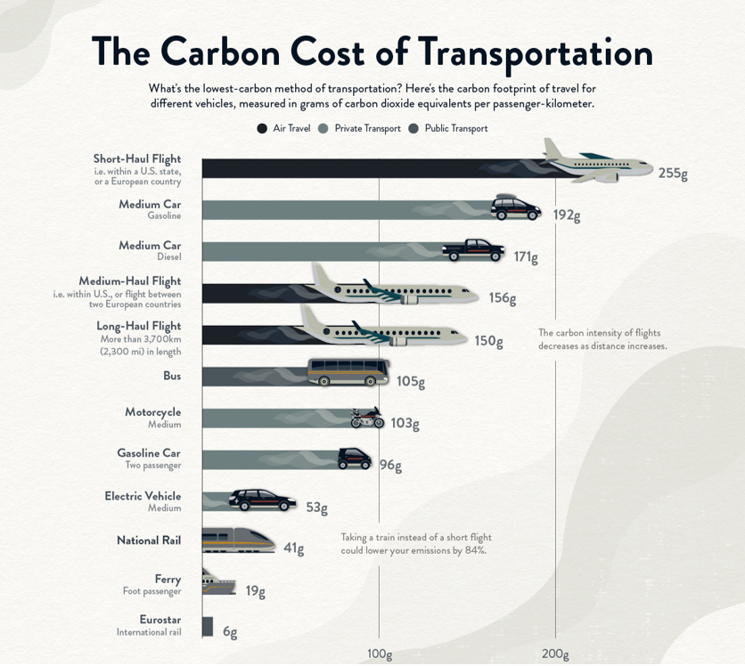

Source: Comparing the carbon footprint of transportation options (Govind Bhutada, 2022)

1. Write a 300 – 400 summary explaining the visualisation to a non-expert/general audience in your notebook.
2. Using your written summary, record a video yourself explaining the visualisation in 2-3 minutes. For instruction on how to add a Padlet video submission, please see this Padlet: How do I post an image or video on Padlet guide.